**Table of Contents**

**Pet Care Online** 2

**Abstract:** 2

**Introduction:** 2

**What is the facility of taking care of Pets?** 3

**Scope:** 3

**Purpose:** 3

**Product perspective:** 3

**Software Requirements:** 3

**Requirements:** 4

**Functional Requirement:** 4

**Non-Functional Requirements** 4

**System Design** 5

**Project Diagrams:** 6

**DFD level zero diagram:** 6

**Class Diagram:** 7

**Use case Diagram:** 7

**ER Diagram:** 8

**Assumptions and Dependencies:** 8

**Diagram of user Interface:** 9

**References** 13

**Figure 1: Class Diagram 7**

**Figure 2: Use case Diagram 8**

**Figure 3: ER Diagram 9**

# **Pet Care Online**

## **Abstract:**

Pet care online software is designed to provide ease to those people who have busy routine and are unable to give time to their pets. The service provides such people with the facility to register their pets on the online portal once the pet gets registered the owner can choose the care taker from the list of care takers that are available at the time when owner of the pets requires them. After checking the details of the care taker the owner of the pet can assign his pet to the care taker and the session is started at the end of the day the care taker give back the pet to its owner when the session is over. In this way people can move, work and travel at any time and at any place without worrying about their beloved pets as they know they are in a supervision of professionals.

## **Introduction:**

Every day, people face the issue of how to deal with their pets when they get disrupted by travel, disease or family emergencies. Others think that it is vital to provide their dogs with healthy social environments when at work or away during the day. Some animal owners only take pets on their way to see that hotel restrictions, animal travel or runaway pets will make your trip a disaster. Some animal owners transform their animals into well-meaning but untrained neighbors and companions when they are working or on holiday. Once again, the findings are mostly unreasonable. Animals entrusted to these part-time custodians often escape or become critically ill because of lack of reliable, regular, and knowledgeable monitoring (edepot, 2020).

Fortunately, the majority of pet owners in need of animal care use the services of professional animal care facilities. Millions of animals’ owners understand that the most reliable, stable and secure animal care services available are full time, competent, and experienced animal care operators. Aside from conventional boarding facilities, pet owners now have more possibilities than ever since dog kitchens provide supervised environments, in which groups of friendly dogs from various families communicate and can play in adjoining buildings or courtyards during the day.

The purpose of the project is to provide the facility to pet owners so that they can make themselves comfortable and feel secured from their pets when they have to move somewhere for work or anywhere where they cannot take their pets with themselves. The service will be online in which the pet owner will register himself and provide the all the necessary details of him and his pet. After getting registered he will get logged in with his account and search for the available care taker and then after fixing a meeting the pet will be provided to the care taker who will take care of that pet until the owner come back to take it (edepot, 2020).

The two goals of the system are:

* To offer a healthy and happy boarding experience for your animals, and
* In order to allow you to enjoy your time away from your house, your pet gets the best treatment possible.

## **What is the facility of taking care of Pets?**

Pet boarding and daycare facilities are establishments specially built and run to care for pets, as distinct from breeding facilities dedicated to the production of puppies; training facilities for hunting, protective dogs, and other specialist training types; and veterinary clinics designed to take care of the aged and the sick. In most of the pet care programs, a range of pet services are offered, including boarding, pet-care, care, obedience training and pet delivery. Although a large majority of the boarded animals are dogs and cats, several facilities also provide horses, birds, reptiles and other exotic animals boarding facilities (edepot, 2020).

The system will try to provide all these facilities in a digitalized manner. Here digitalization is meant to be making each and every thing which are the part of service online or on internet.

## **Scope:**

This project will provide the services to all the pet lovers and will help them to manage their work and their pets. It will make the day care service online which will save the time as well as traveling cost of those who want to get the services of day care for their pets. Some of the area that will be covered by the project are:

* Updating the day care services for pets from manual to web based system.
* By using the system, the pet owners will be able to know about the care taker who will take care of their pets when they are not available to them.
* The system will allow the user to get register and then add his pet in the system.
* The owner can view the available care takers to assign their pets to them.

## **Purpose:**

The main purpose of the project is to provide the facility to those people that have jobs or want to travel at some place or are busy in some work and are not able to take proper care of their pets. The idea is simple that there will be an online portal in which pet owner will get registered by providing each and every detail of himself and also the details of his pet animal then a list of care takers who are available for providing the facility of taking care of these pet animals will be shown to the owner. The owner will select one of the care taker from that list and provide his pet to that person who will take care of that pet until the owner get back. In this way people can work without any external tension of their pet animals and pet animals will also be in safe hands where they get proper care and all the facilities that they need (g2, 2020).

## **Product perspective:**

The system will provide the user that is the owner of any pet animal with the care taker who has experience in care taking of that particular pet. User can search the desired care taker who has experience in taking of that particular pet the owner has. In this way there will be proper facility and care provided to that pet making the owner satisfied (packagedfacts, 2019).

## **Software Requirements:**

* Front End:
  + ASP.NET
  + C#
* Back End:
  + SQL Server

## **Requirements:**

Requirements for the system are categorized in two types these are:

* Functional Requirements
* Non-Functional Requirements
* External System Requirements

## **Functional Requirement:**

* **R.1.1: Register:**
  + The user will get registered with the system.
* **R.1.2: Login**
  + Input: Enter the valid credentials of user
  + Output: After successful login the user will be able to access the system features
* **R.2:** The user manages the Care taker.
* **R.2.1: Add/Delete Care Taker:**
  + The care taker is registered with the system and can be deleted in case of any situation.
* **R.2.3: Add Pet:**
  + New pet can be added into the system and all the details of the pet are given so that the care taker can read all the information of the pet that is entered and take care of that pet accordingly.
* **R.2.4: Delete Pet:**
  + The pet can also be deleted in case the care taker work is done with the particular pet
* **R. 2.5: Start of Session:**
  + Once the care taker has assigned a pet the session is started. The session actually means that the care taker is reserved with that particular pet. The session will automatically come to end once the owner of that particular pet come back for taking the pet along with.
* **R. 2.6: View:**
  + The user can view all the information and the details about the particular care taker to whom he wants to provide his pet for the purpose of care taking.
  + The care taker can also view all the details of a pet that are been added in the list of pets.
* **R. 2.7: Session details:**
  + All the details related to the session can be viewed in which the details about the pet the care taker detail to whom the pet was assigned the time and date of session start and the end time of session can be viewed.

### **Non-Functional Requirements**

It explains the system aspects relevant to how the system meets the functional requirements. Following are some non-functional requirements of the system:

* The system shall allow the user to access the system from the web interface. The web application will be used as an interface for the system. The special training is not required as the system is user friendly and it is easy to adopt the system.
* The system should have the high level of performance when dealing with the customer input and should be able to response back to the customers feedback in short span of time.
* Errors should be handled in an appropriate way. Error rate should be minimized as much as it can be. There must be an appropriate error message for the customers. The time to recover from an error should also be as much less as it can be.
* The availability of the system should be any time anywhere so that customer can be able to use the system at the time, he wants it. If in case any malfunction occurs system should be recovered as soon as possible so that business is not severally affected by this.
* System should be user friendly interface should be developed in a way that anyone with even less knowledge of system can use it **Invalid source specified.**.

## **System Design**

Systems design is the process of defining the system to satisfy defined needs of architecture, components, modules, interfaces and data. Systems design may see it as a product development application of system theory. The fields of system analysis, system architecture and system engineering are overlapping. If the wider theme of product development "miscalls the marketing, design and production perspectives into a single product development strategy," then design is the process of taking marketing knowledge and designing the product to be produced. Therefore, system design is a method for system definition and development for the purpose of satisfying the need of the customer.

According to the given requirements in this phase a logical system is made. In software development the design phase is the phase where user requirements are converted into logical modules, usually it occurs in two phases these two phases are

* Primary Design
* Secondary Design

#### **Primary Design:**

A block level of system is design in this phase. On the basis of problem that are identified in the in the problem identification phase blocks are created. Different blocks are created for different functions. Each block represents a specific module or functionality.

#### **Secondary Design:**

In this phase a detailed design of each and every module or block is performed.

#### **Tasks involved in the design phase:**

* For overall system processes various blocks are designed
* Each block consists of small, compact and working modules
* Database structures related to specific modules are designed
* To achieve the desired functionality details of program are specified
* Input and output forms of the system are designed
* Design documentation is made
* Detailed review of system design is done

## **Project Diagrams:**

Pet owner

## **DFD level zero diagram:**

The information of session, pet and care taker is retrieved from the database whenever it is needed

Update the information of session, pet and care taker in the database of the system

Gets register with the system

Provide the details of pet and its owner

Provide the details of care taker

Register/ Login into the system

Pet Care Online

System’s Database

Care Taker

## **Class Diagram:**

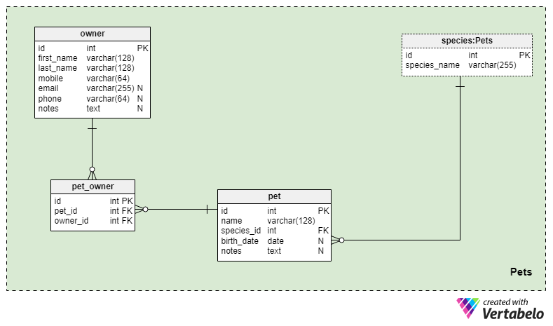

Figure 1: Class Diagram

## **Use case Diagram:**

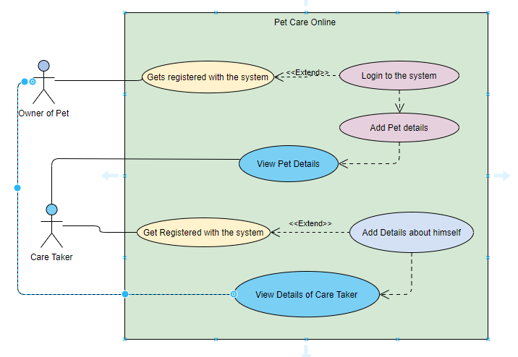

Figure 2: Use case Diagram

## **ER Diagram:**

A model of entity-relation (ER model) describes interrelated interests in a particular area of information. An ER model is made up of entities (classifying the subjects of interest) and defines relations between entities of these kinds. In order to execute business processes, an ER model is typically developed to reflect items a company needs to remember. The ER model becomes therefore, usually relational database, an abstract model which defines the data or information structure that can be implemented in a database.

The key components of the ER model are: set of companies and set of relationships.

This diagram contains geometric forms and their significance.

Right-clock: Represents Sets of Entity.

Ellipses. Ellipses: Attribute.

Diamonds: Collection of relations.

Lines: They attach Entity Sets attributes and this to Relation Set.

The ER diagram for the system Pet Care Online is as follow:

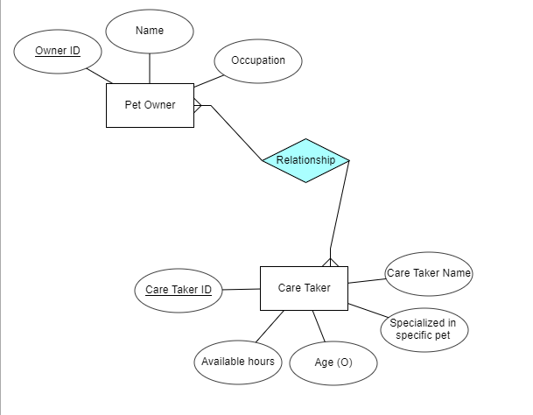

Figure 3: ER Diagram

## **Assumptions and Dependencies:**

The product needs the following third-party applications for the development of the system:

* Visual studio
* SQL Server

## **Diagram of user Interface:**

The registration interface enable user to get register with the system in order to use it and get facilitated the user have to input his Email and Password and then have to click the Register button in order to get registered. By registering himself the user can facilitate himself with the system.

The interface consists of the login screen where user have to put the right credentials that he had used at the time of registration he is to provide the email address that he used during the registration process and then by entering the correct password the user can log into the system. Just down the login button there are three different links that can take the user to different interfaces the first one is forgot password in case the user forgets his password he can use the link to retrieve it again. Using second link the user can register himself. This link will take the user to the Registration page.

Here the new care take can be created for the purpose of taking care of the pets of different people. The name and phone number of the care taker should be added here and then the create button can create the new care taker.

Similar to the screen there is a screen where the user can enter the details about the pet. The type, category and nickname etc. of the pet is asked by the system via form which the user has to fill up after that the pet gets registered with the system.

On this screen one can view and manage the list of all the care takers. From this interface the user can edit the existing care taker details. He can delete an existing care taker and can check the details about that particular care taker.

The user can manage the details of pets also. Once a pet is added in the system the user can edit the details of that particular pet. He can also delete any pet, and can also view the details of that particular pet.

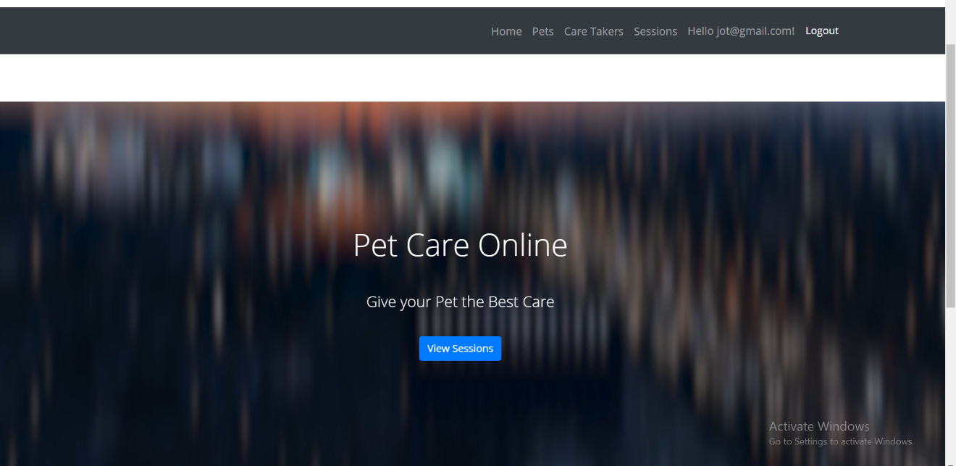

Here one can view the sessions, sessions are basically the time period during which one pet is assigned to the care taker until some specific time span by which the user get back to his pet and bring him back to his own place. By clicking on view sessions button, the user can view all the available sessions that are currently engaged. All the occupied care takers and pets are found here.

The user can also manage all the sessions here is the interface by which the user can manage the sessions of the pet and care takers. The table above shows that a pet is assigned to a care taker and just in front of them a session starts time and the end time of the session is also noted. This is how the system manages different care takers and pets at the same time. The user can edit, view or can also delete the details of a particular session.

# **References**

edepot. (2020). *edepot.wur.nl*. Retrieved from Day care for pet: https://edepot.wur.nl/1462

g2. (2020). *www.g2.com*. Retrieved from pet-sitting-and-daycare: https://www.g2.com/categories/pet-sitting-and-daycare

packagedfacts. (2019). *www.packagedfacts.com*. Retrieved from Digital-Pet-Care-Products-Services-commerce-connectivity: https://www.packagedfacts.com/Digital-Pet-Care-Products-Services-commerce-connectivity-13518751/